

**SMART DUSTBIN**

**IOT PROJECT**

**SUBMITTED TO- DR. MANOJ UKAMANAL**

**SUBMITTED BY- GROUP 1**

**ANISHA ROY(2205014)**

**AYUSHI SINGH(2205026)**

**TANYA SHARMA(2205076)**

**SMART DUSTBIN USING ARDUINO**

INTRODUCTION:

The population in our country is rapidly increasing, leading to a rise in garbage and environmental issues. Dustbins are containers that collect and store both recyclable and non-recyclable items, as well as decomposable and non-decomposable waste. While they are commonly used in homes and offices, if they become full, there is often no one available to clean them, resulting in spilled garbage. This contributes to pollution levels in the surrounding area. Additionally, dustbins can cause air pollution by harboring bacteria and viruses that can lead to harmful diseases for humans. To address these issues, we have developed a smart dustbin using an Arduino Uno and an ultrasonic sensor. This innovative project utilizes IoT technology to provide a new and intelligent approach to cleanliness. It's a great gadget to keep your home clean, especially since children find it interesting and fun. The smart dustbin will open its lid when an object is detected nearby and automatically close after a set time period. This ensures that the lid remains closed when not in use and opens only when necessary.

METHODOLOGY:

SMART DUSTBIN USING ARDUINO is an IOT based project. Here we are using arduino for code execution, for sensing we used ultrasonic sensor which will open lid and wait for few moment. So this help in maintaining the environment clean with the help of technology. It is a sensor based dustbin so it would be easy to access use for any age group. Our aim is also to make it cost effective so that many numbers of people can get the benefit from this. And it should be usable to anyone and helpful for them.To complete our project, we require some software as well as some hardware. Required Software:ARDUINO IDE

Required Hardware: 1. ESP32

2.ULTRASONIC SENSOR

3.SERVO MOTOR

4.9V BATTERY

5.DUSTBIN

6.JUMPER WIRES

PROCEDURE:

SERVO MOTOR CONNECTION SETUP: Now, let me take you through the actual setup and build process of the Smart Dustbin using Arduino. First, I will start with the mechanism to open the lid. As you might have already guessed, I have used a Servo Motor for this purpose. In order to open the lid, I have fixed a small plastic tube (like an empty refill of a ball-point pen) to the servo horn (a single ended horn) using instant glue. For this mechanism to be able to open the lid of the dustbin, it must be placed near the lid. In this the actual setup of dustbin design and build the system by using Arduino. Starting with the mechanism of opening the lid of dustbin, for this purpose Servo motor has been used.To open the lid, I have attached a small plastic tube (like an empty refill of a ball-point pen) to the servo horn (a single ended horn) using instant glue.

ULTRASONIC SENSOR CONNECTING:

After successfully servo motor is placed now it’s time for sensor, so HC-SR04 Ultrasonic sensor is placed at the front of the dustbin.

WIRING UP THE COMPONENTS:

The final step in the build process is to make the necessary connections using long connecting wires as per the circuit diagram and securing these wires so that they don’t hang around. All the wires from both the components i.e. Ultrasonic Sensor and Servo Motor are connected to respective pins of Arduino. This finishes up the build process of the Smart Dustbin.In Arduino Code has been submitted, and with all hardware and software connection in Dustbin. We will run our dustbin, wait its working or not.

CIRCUIT DIAGRAM:

The smart dustbin circuit comprises an Arduino Uno board, which houses the ATmega328P microcontroller as its core component. Alongside, it includes a power supply, ultrasonic module, and servo motor. The ultrasonic sensor's echo and trigger pins connect to digital pins D7 and D8, respectively, while the +Vcc pin links to a +5V supply, and the GND pin connects to the Arduino Uno's ground pin. The servo motor's control (PWM) pin connects to digital pin D9 of the Arduino board, facilitating the opening of the dustbin's cap. For this project, the preset distance between the dustbin and a hand/object is fixed at 40 cm.

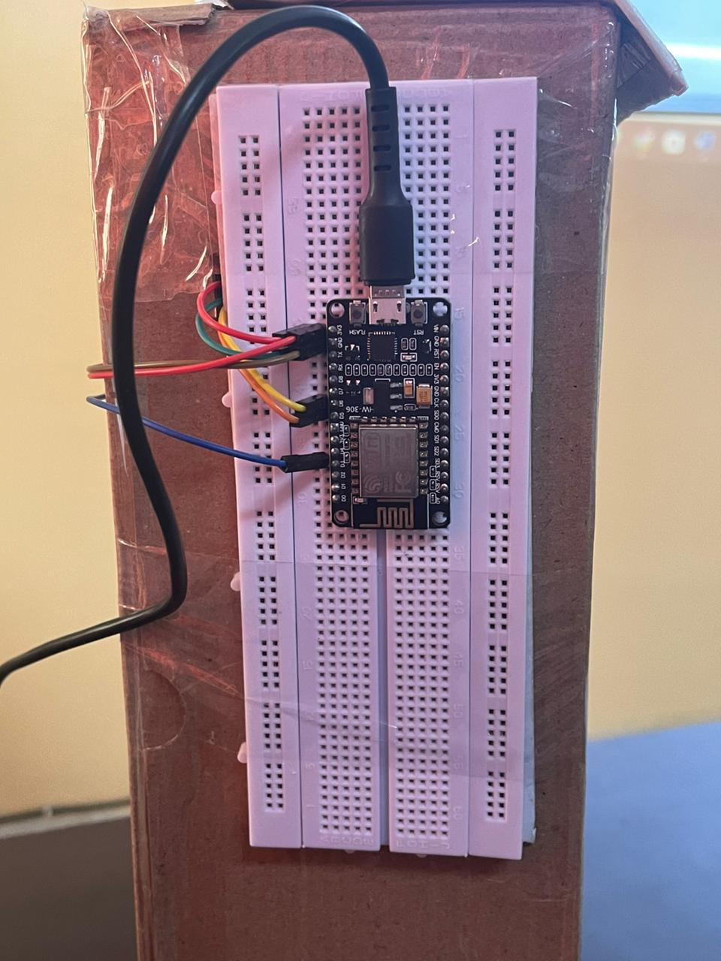

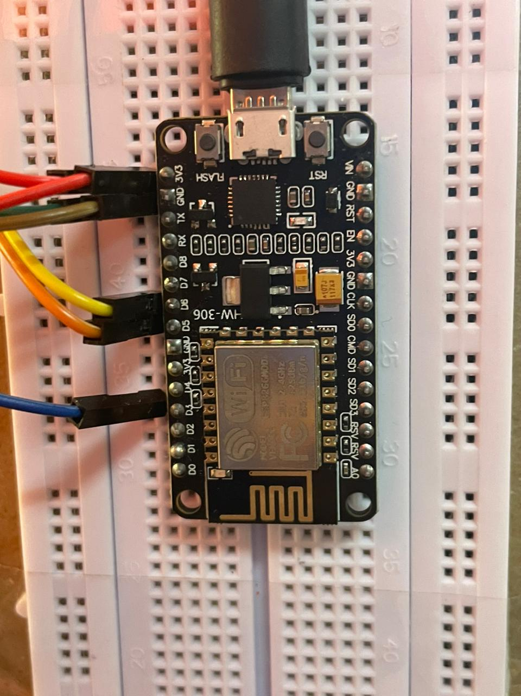

The ultrasonic sensor functions by detecting obstacles, such as hands, using sonar waves. It initiates obstacle detection when the trigger pin receives a high pulse lasting more than 10 microseconds. Upon verification of the obstacle's presence, the sensor emits eight cycles of ultrasonic bursts at 40 KHz and waits for the reflected ultrasonic signal. With two drums, one for transmitting and the other for receiving ultrasonic signals, the module sets its echo pin high upon sensing an object. The duration of the reflected pulse determines the waiting period, which correlates directly with the obstacle's distance. By utilizing the formula Distance (in cm) = (duration/2) / 29.1, we can accurately calculate the distance to the obstacle.Initially, the cap of dustbin is switched back to zero-degree position (Close) by the servo motor. The controller keeps on monitoring the signal receive from ultrasonic module. When ultrasonic module detects an obstacle, the controller check if it crosses a threshold distance value set for open the cap of dustbin. As soon as that happens, the controller triggers the servo motor when then open the cap for limited line (as set in code part). For this system prototype set time is given for 2 second. Here in this project also used an ON/OFF switch, in order to activate and de-activated the smart dustbin whenever require as per situation. A pullup resistor of 10K is connected in series of switch as shown in circuit diagram in order to solve the de-bouncing problem. We can also use Arduino NANO instead of Arduinouno. Do not have to change source code because the board use identical pin for controlling servo motor, switch and ultrasonic sensor. The simplest part of the project smart dustbin using arduino is software part because it is clean, simple and easy to understand. The program check the distance had also used “Servo.h” inbuilt library function for servo operation. It can assume any value of motor rotation using “myServo.write(angle)” function but here we had only use two state of position (1) zero degree and (2) 1800.

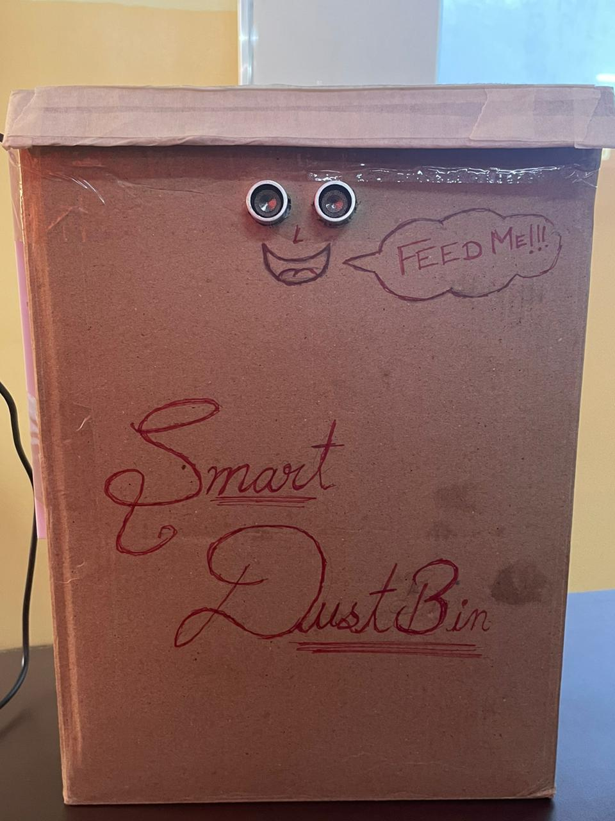

WORKING:

After wiring and attaching all the devices and setting up to the Smart Dustbin, now observe all the important setup whether they are well connected or something missed. After connection set up now next step is to submit/upload code in Arduino and supply power to the circuit. When system is powered ON, Arduino keeps monitoring for any things that come near the sensor at give range. When Ultrasonic sensor detect any object for example like hand or others, here Arduino calculates its distance and if it less than a certain predefines value than servo motor get activate first and with the support of the extended arm of the lid. Lid will open for a given time than it will automatically close.

Arduino IDE CODE:

#include <Servo.h> // servo library

#define BLYNK_TEMPLATE_ID "TMPL3J08rAmJm"

#define BLYNK_TEMPLATE_NAME "switch"

#define BLYNK_AUTH_TOKEN "EYGzNqiX5zLpA4YOeLlJJSE4Bbtncdqv"

#define BLYNK_PRINT Serial

#include <ESP8266WiFi.h>

#include <WiFiClient.h>

#include <BlynkSimpleEsp8266.h>

Servo s1;

const int trigPin = D5;

const int echoPin = D6;

char ssid[] = "Tanya";

char pass[] = "Tannu2307";

long duration;

int distance;

void setup()

{

s1.attach(0); // servo attach D3 pin of arduino

pinMode(trigPin, OUTPUT); // Sets the trigPin as an Output

pinMode(echoPin, INPUT); // Sets the echoPin as an Input

Serial.begin(9600); // Starts the serial communication

Blynk.begin(BLYNK_AUTH_TOKEN, ssid, pass);

}

void loop()

{

// Sets the trigPin on HIGH state for 10 micro seconds

digitalWrite(trigPin, HIGH);

delayMicroseconds(10);

digitalWrite(trigPin, LOW);

// Reads the echoPin, returns the sound wave travel time in microseconds

duration = pulseIn(echoPin, HIGH);

// Calculating the distance

distance= duration*0.034/2;

// Prints the distance on the Serial Monitor

Serial.print("Distance: ");

Serial.println(distance);

delay(200);

if(distance<15)

{

s1.write(180); // open the dustbin

delay(2000);

}

s1.write(0); //close the dustbin

Blynk.run();

}

BLYNK_WRITE(V1)

{

int pinValue = param.asInt(); // assigning incoming value from pin V1 to a variable

if(pinValue==1)

{

s1.write(180);

delay(2000);

}

else

s1.write(0);

// process received value

}

ADVANTAGES:

Following are the advantages of using Smart dustbin: A reduction in the number of waste collections needed by up to 80%, resulting in less manpower, emissions, fuel use and traffic congestion. A reduction in the number of waste bins needed.Maintain environment hygiene (i.e. no overflowing of waste and less unpleasant odor).It will help in bringing evolution by technology in term of cleanliness.

RESULT:

The integration of intelligent waste monitoring and trash compaction technologies has led to the development of smart dustbins, marking a significant advancement over traditional garbage bins. These innovative bins are equipped with sensors and Arduino technology, allowing for automated lid opening when an object approaches and subsequent closure after a set time period. This advancement not only promotes cleanliness but also contributes to health and hygiene on a societal level. Moreover, by striving to make this technology accessible and affordable, it ensures that individuals from all walks of life can benefit from its usage. The inclusion of additional sensors to detect bin capacity and the addition of a display for user notification further enhance the functionality of these smart dustbins. Overall, these developments hold promise for transforming cleanliness practices and integrating technology for societal betterment.

CONCLUSION AND SUGGESTION:

Here we are going to make an evolution changes toward cleanliness. The combination of intelligent waste monitoring and trash compaction technologies, smart dustbins are better and shoulders above traditional garbage dustbin. It is equipped with smart devices like sensor Arduino etc.Lid of the dustbin will automatically open when an object comes near to the dustbin and after certain time period it will close the lid. For social it will help toward health and hygiene, for business for we try to make it affordable to many as many possible. So that normal people to rich people can take benefit from it. Believe this will bring something changes in term of cleanliness as well technology.So our next work will be adding one more sensor which will sense whether our dustbin is full or not. And there will be a display will be added so that user can notify that dustbin is full or not.